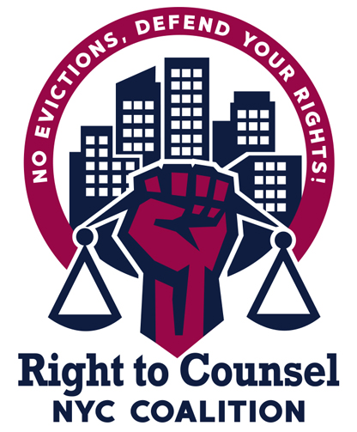

RTCNYC Tool 12.4.5 Law School Roadshow Presentation Outline

- Presentation Plan
  - Start by showing one of the short videos. If possible to set up beforehand with school.
    - Documentary trailer (2 min)
    - Documentary (50 min)
    - Campaign video (5 min)
    - Campaign video (3 min)
- Opening Questions
  - Ask some questions of the group to get a feel for who’s in the room by show of hands
    - 1L, 2L, 3L?
    - Experience with housing/representing/advocating for tenants vs. none?
    - Has anyone been to housing court (as an advocate, friend, student, etc)?
    - Has anyone been harassed or discriminated against by a Landlord and/or Management Company?
    - Who has had difficulty getting repairs?
- Tenant Leader and/or Organizer
  - Explain what the Right to Counsel Coalition is
  - How you got involved in housing rights + what you do + role in coalition
  - Give the background of why tenants fought for RTC and how it was won
  - Give overview of current organizing efforts and new RTC bills
  - Tenants’ vision for RTC (personal story would work well here)
  - How can lawyers support tenant groups/community organizers
  - How can tenant groups/community organizers support the work lawyers do?
  - Explain what it is like to be a tenant in housing court and how has the culture changed & not changed
    - How will lawyers (the new generation of community lawyers) be part of this shift?
- Lawyer
  - How you got involved in housing rights + what you do + role in coalition
  - Discuss implementation, pipeline working group
  - Discuss some of the recent victories of the tenant movement
    - How did this change things
    - How did this affect the ongoing campaign
  - Day to day of civil legal aid attorneys practicing housing
  - Culture of housing court, race and gender, normalization of evictions and the role that plays in gentrification/displacement
  - What types of experiences are valuable for law students to get while in law school?
  - What is the hiring process like for graduates?
  - Discuss the fact that there are lots of jobs out there now and that it’s an exciting career opportunity to get in on the ground floor of a rapidly growing area of practice that can be transformative for clients and their communities
- Q&A with students
- CALL TO ACTION!
  - Tenant Leader &/or Organizer: discuss how important having an attorney in housing court is, what an important and exciting moment this is, and how we need zealous attorneys who are interested in engaging with the communities they serve
    - Ask for commitment to support any current campaigns
    - Get involved in RTC and campaigns related to Housing as a Human Right

