END UNJUST EVICTIONS!!!
REFORM HOUSING COURT!!!
NYC, PASS “INTRO 214-A”!!!
“INTRO 214-A” WOULD GIVE NEW YORKERS THE RIGHT TO LEGAL REPRESENTATION WHEN FIGHTING FOR THEIR HOMES IN HOUSING COURT!
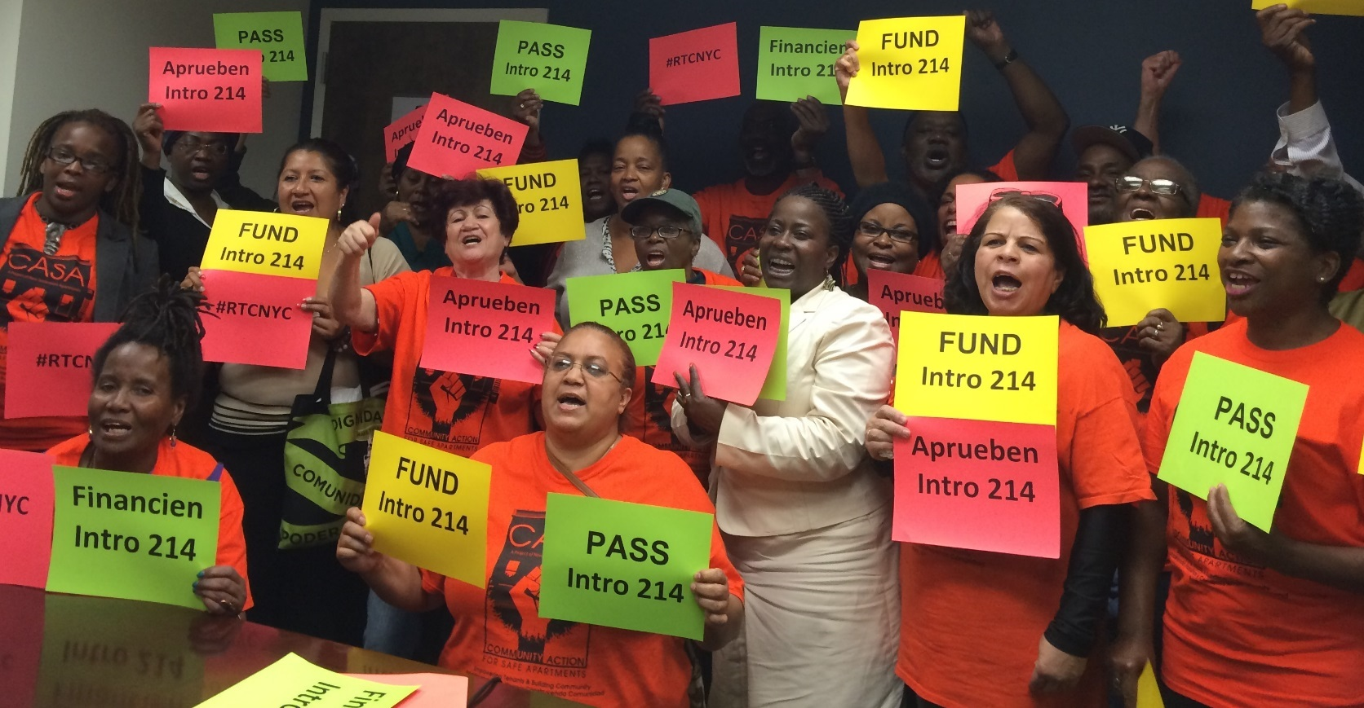

PRESS CONFERENCE AND CITY COUNCIL HEARING:
When: Monday Sept 26th
Meet CASA at 35 Marcy Place
(corner of Walton Ave.)
8:30AM SHARP!
Breakfast and metrocards provided.

WE NEED YOU TO HELP PASS “INTRO 214-A”!

* This is your ONLY opportunity to testify in front of city council to demand “Intro 214-A”
* NYC could save up $320 Million!!!
* Stop landlords from bringing frivolous court cases and harassment
* We can change the balance of power in housing court, where 90% of landlords have attorneys, while most tenants don’t!
http://www.righttocounselnyc.org
Need help with prepping testimony? Need an orientation on the Right to Counsel? Contact Susanna! Attend prep meeting on Tues. Sept 20th, 6:00pm at 35 Marcy Pl

